Assignment – 8.5

Lab 8: Test-Driven Development with AI – Generating and Working with Test Cases
Name: U. Rohith
HT No: 2303A52198
Batch: 35
Week 4: Friday

Lab Objectives
- To introduce students to Test-Driven Development (TDD) using AI tools.
- To generate test cases before writing Python implementations.
- To reinforce the importance of validation, testing, and error handling.
- To encourage clean and reliable code based on AI-generated test expectations.
Task 1: Username Validator (Authentication Context)
AI-Generated Assert Test Cases
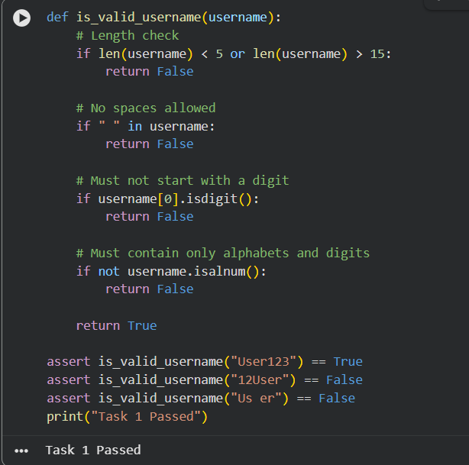

Task 2: Even–Odd & Type Classification
AI-Generated Assert Test Cases
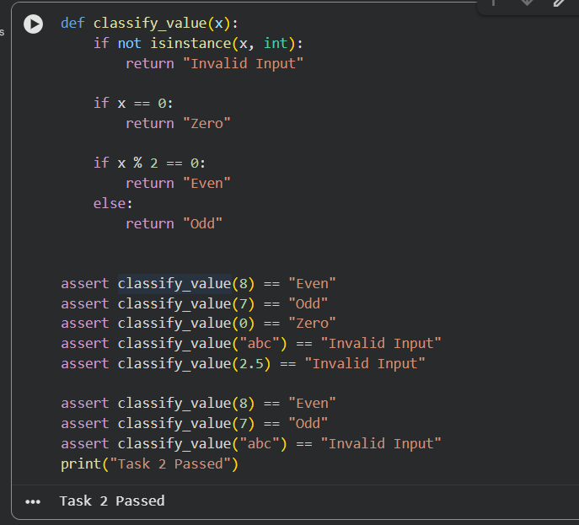

Task 3: Palindrome Checker (String Normalization)
AI-Generated Assert Test Cases
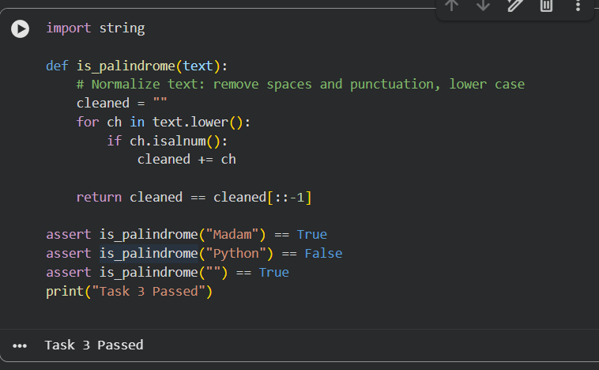

Task 4: BankAccount Class (Object-Oriented TDD)
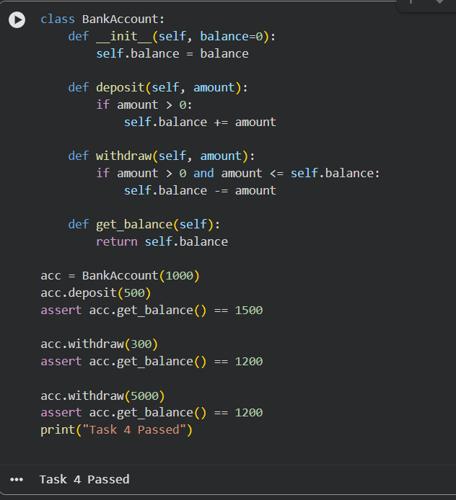

Task 5: Email ID Validation (Data Validation)
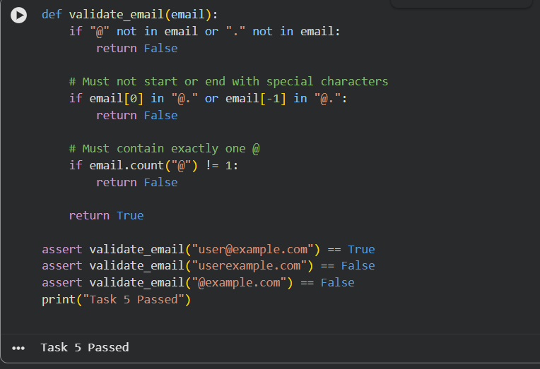

Final Conclusion
This lab successfully demonstrated Test-Driven Development using AI-generated assert test cases. Writing tests before implementation improved correctness, reliability, and error handling. AI-assisted test generation was useful, but human verification was necessary to ensure complete coverage and logical accuracy.

